Mapping old to new EIGT structure

1. Top marginal rates + Estate Tax or Inheritance:

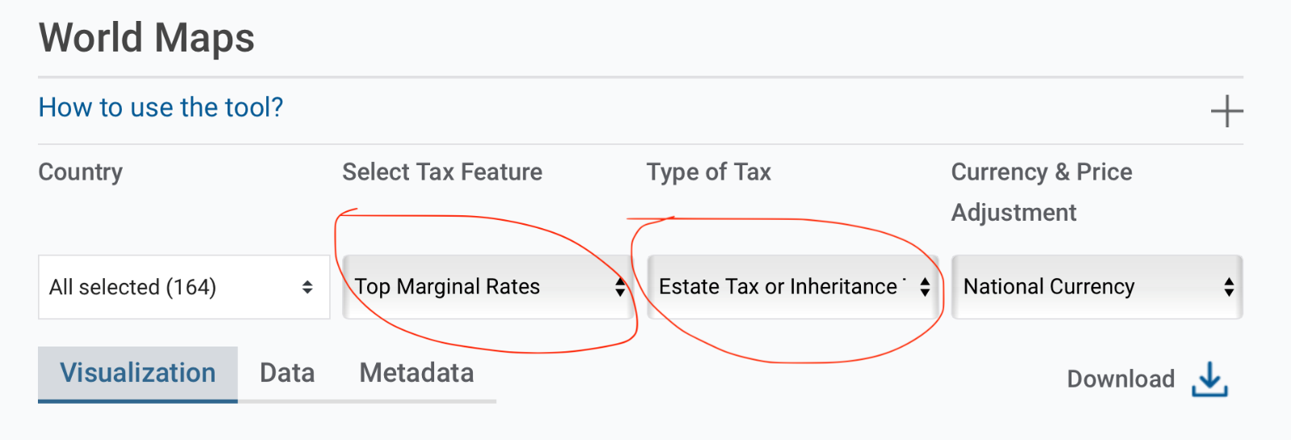

In the old setting - from eigt_wide_viz - this corresponds to:

Value of x_hs_rat_toprat IF x_hs_cat_eigsta == “Y“

In the new setting we have the following structure of eigt_wide_viz_v2:

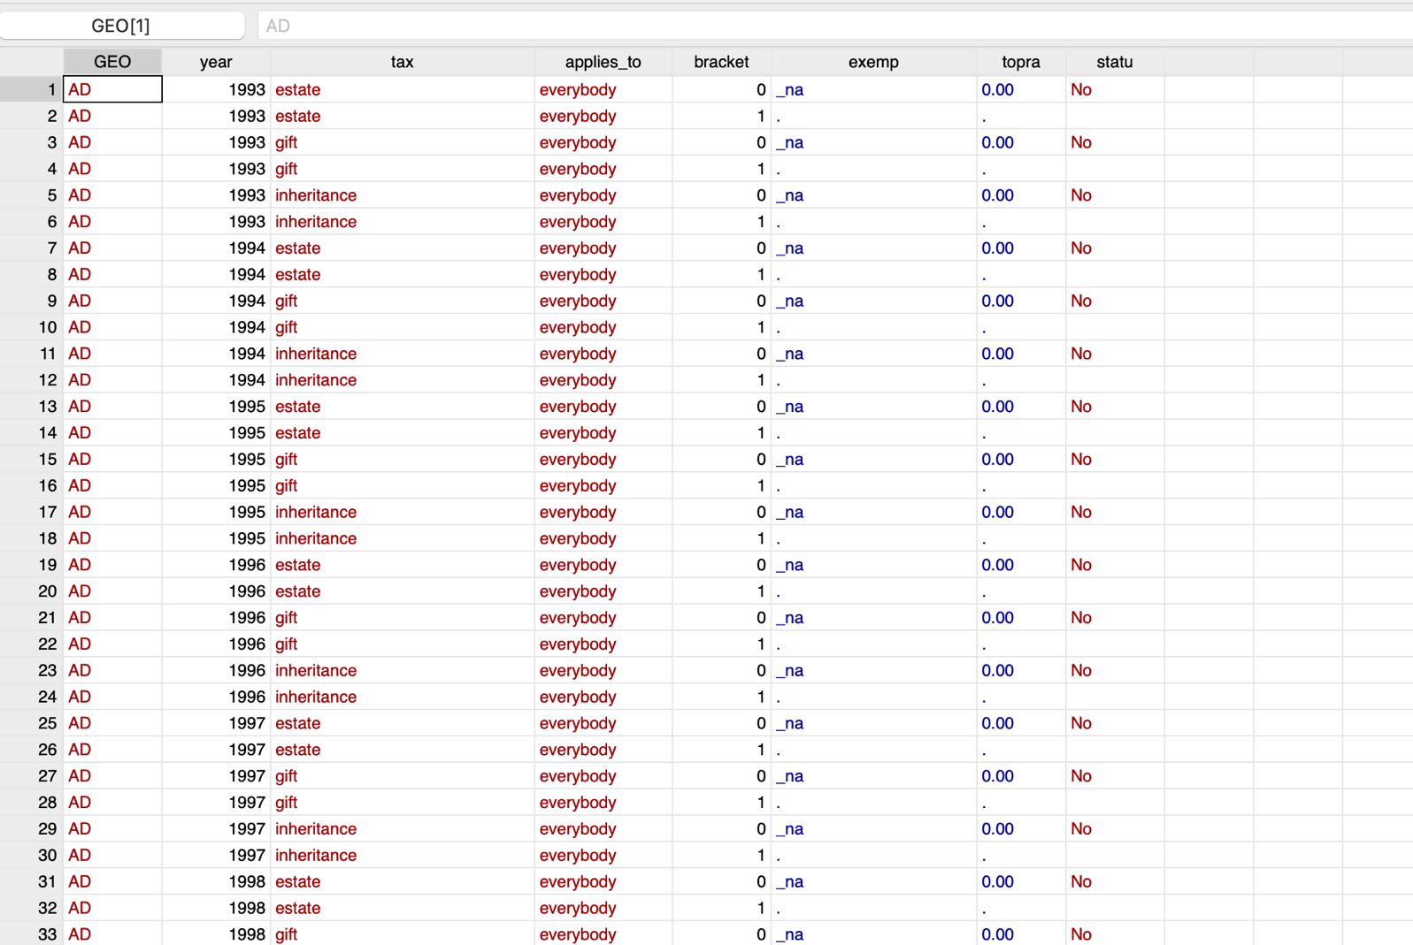

Therefore, in the current wide_viz_v2 we have that ONLY the following variables are STRINGS:
GEO, tax, applies_to, status, curren, typtax, homexe (whith the last two not involved in the website mapping)

All the other variables are numeric.

To replicate the graphical representation of the previous case, we would need the following condition:

Value of toprat IF (tax=="estate" | tax=="inheritance") & status=="Yes" & (applies_to == “everybody” | applies_to == “children”)

In terms of dta, taking for example the case of Germany 2020, in the wide_viz we have:

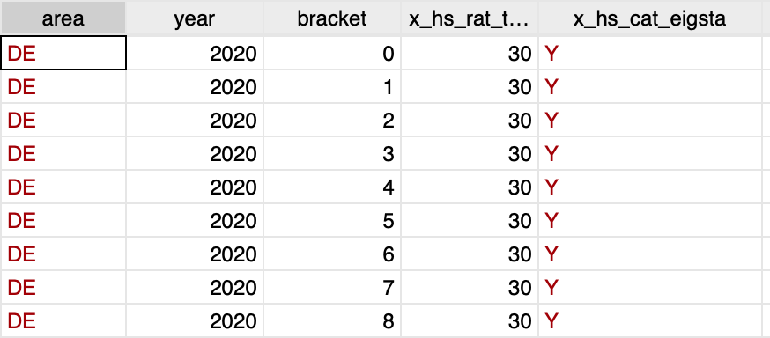

While in wide_viz_v2.dta we have the following:

2. Top marginal rates + Estate Tax (Inheritance):

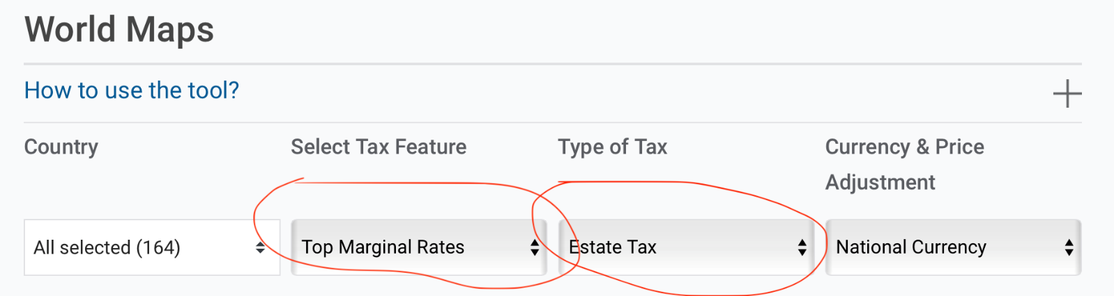

In the old setting - from eigt_wide_viz - this corresponds to:

Value of x_hs_rat_etopra IF x_hs_cat_eigsta == “Y“

(In the case of Type of Tax = Inheritance, then the above condition is: x_hs_rat_itopra IF x_hs_cat_eigsta == “Y”)

In the new setting we have the following condition from eigt_wide_viz_v2:

Value of toprat IF tax=="estate" & status==”Yes” & (applies_to == “everybody” | applies_to == “children”)

(In the case of Type of Tax = Inheritance, then the above condition is: topra IF tax=="inheritance" & status==”Yes” & (applies_to == “everybody” | applies_to == “children”)

Note: Here the underlying assumption is to use children (or everybody) as category of “applies_to”. More possibilities are allowed under the new structure.

3. Exemption threshold + Estate or Inheritance Tax

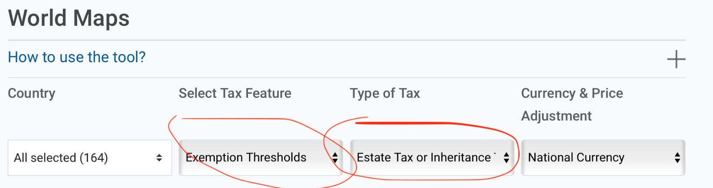

In the old setting - from eigt_wide_viz - this corresponds to:

Value of x_hs_thr_chiexe IF x_hs_cat_eigsta == “Y“

In the new setting we have the following condition from eigt_wide_viz_v1:

Value of exemp IF (tax=="estate" | tax=="inheritance") & statu=="Yes" & (applies_to == “everybody” | applies_to == “children”)

Note: Here the underlying assumption is to use children (or everybody) as category of “applies_to”.

4. Exemption threshold + Estate Tax (Inheritance Tax)

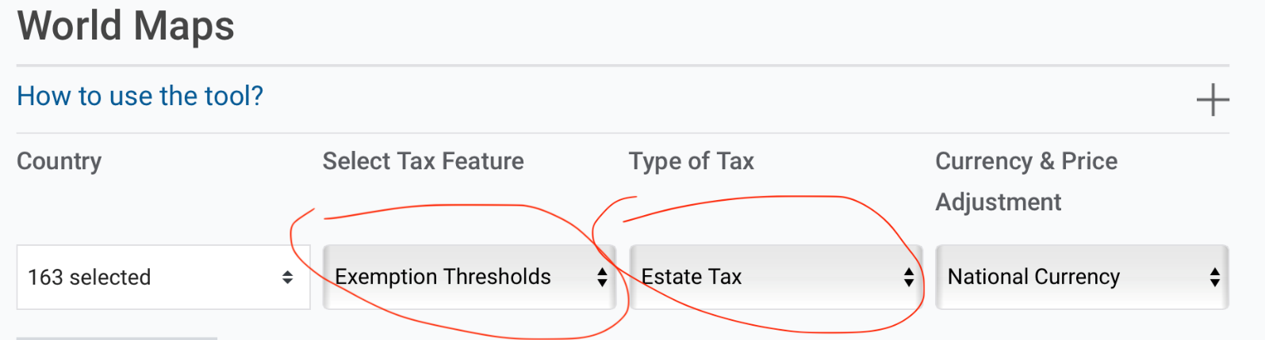

In the old setting - from eigt_wide_viz - this corresponds to:

Value of x_hs_thr_chiexe IF x_hs_cat_esttax == “Y“

(In the case of Type of Tax = Inheritance, then the above condition is: x_hs_thr_chiexe IF x_hs_cat_inhtax == “Y“)

In the new setting we have the following condition from eigt_wide_viz_v1:

Value of exempt IF tax=="estate" & status==”Yes” & (applies_to == “everybody” | applies_to == “children”)

(In the case of Type of Tax = Inheritance, then the above condition is : Value of exempt IF tax=="inheritance" & status==”Yes”)

Note: Here the underlying assumption is to use children (or everybody) as category of “applies_to”.

5. EIG Tax in % of Total Revenue + Estate or Inheritance

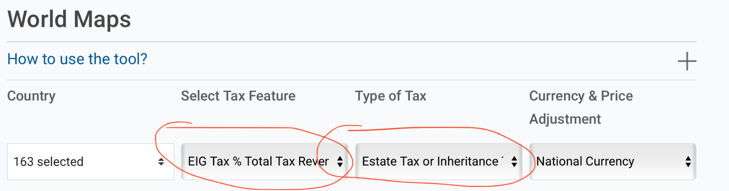

In the old setting - from eigt_wide_viz - this corresponds to:

Value of x_hs_rto_tprrev IF x_hs_cat_eigsta=="Y"

In the new setting we have the following condition from eigt_wide_viz_v2:

Value of prorev_ei IF status=="Yes" & (tax=="inheritance" | tax=="estate")

Note: Here the underlying assumption is to use the general government level in “applies_to”. Or better, we keep the general level revenues when this is not available, we scale down but only when the local/federal is not 0.

6. EIG Tax in % of Total Revenue + Estate Tax (Inheritance Tax)

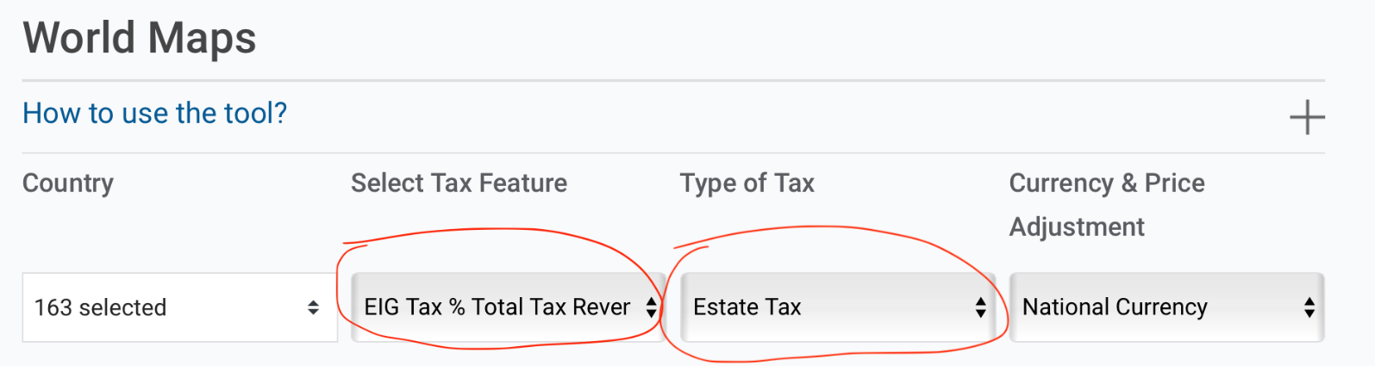

In the old setting - from eigt_wide_viz - this corresponds to:

Value of x_hs_rto_tprrev IF x_hs_cat_esttax== “Y”
(In the case of Type of Tax = Inheritance, then the above condition is: x_hs_rto_tprrev IF x_hs_cat_inhtax == “Y“)

In the new setting we may have 2 different scenarios, depending on which filtering condition we want to introduce. Indeed, as the OECD collects revenue for EIG or for EI, or for gift separately, in the new version we may want to show the Tax in % of total tax revenue as for EIG, EI or gift separately.

In this 1st scenario, with eigt_wide_viz_v2 we have:

Value of prorev _eig IF n_tax==3 - for EIG
Value of prorev_ei IF (tax==”inheritance” & status==”Yes”) | (tax==”estate” & status==”Yes”) - for EI
Value of prorev_g IF (tax==”gift” & status==”Yes” ) - for Gift

Note: Here the underlying assumption is to use the general government level in “applies_to”. Or better, we keep the general level revenues when this is not available, we scale down but only when the local/federal is not 0.

In a 2nd scenario we can replicate estate and inheritance separately (but each including gift as well, as we do not have information separately):

Value of prrev_eig IF (tax=="estate" & status=="Yes") & (n_tax>=1 & gift_yes==1) – Filter on estate
Value of prrev_eig IF (tax=="inheritance" & status=="Yes") & (n_tax>=1 & gift_yes==1) – Filter on inheritance

7. EIG Tax Revenue + Estate or Inheritance

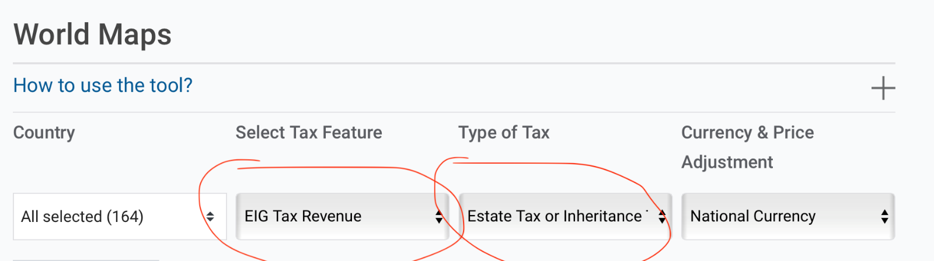

In the old setting - from eigt_wide_viz - this corresponds to:

Value of x_hs_agg_totrev IF x_hs_cat_eigsta=="Y"

In the new setting with eigt_wide_viz_v:

Value of revenu_ei IF status=="Yes" & (tax=="inheritance" | tax=="estate")

Note: Here the underlying assumption is to use the general government level in “applies_to”. Or better, we keep the general level revenues when this is not available, we scale down but only when the local/federal is not 0.

8. EIG Tax Revenue + Estate Tax (Inheritance)

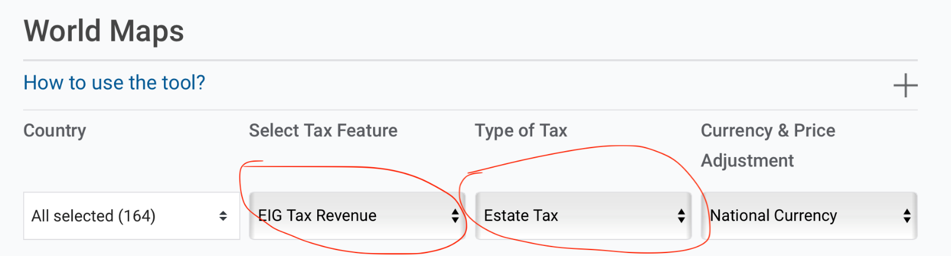

In the old setting - from eigt_wide_viz - this corresponds to:

Value of x_hs_agg_totrev IF x_hs_cat_esttax== “Y”
(In the case of Type of Tax = Inheritance, then the above condition is: x_hs_agg_totrev IF x_hs_cat_inhtax == “Y“)

In the new setting we may have 2 different scenarios, depending on which filtering condition we want to introduce. Indeed, as the OECD collects revenue for EIG or for EI, or for gift separately, in the new version we may want to show the Tax in % of total tax revenue as for EIG, EI or gift separately.

In this 1st scenario, with eigt_wide_viz_v1 we have:

Value of revenu_eig IF n_tax==3 - for EIG
Value of reven_ei IF (tax==”inheritance” & statu==”Yes”) | (tax==”estate” & status==”Yes”) - for EI
Value of revenu_g IF (tax==”gift” & status==”Yes” ) - for Gift

Note: Here the underlying assumption is to use the general government level in “applies_to”. Or better, we keep the general level revenues when this is not available, we scale down but only when the local/federal is not 0.

In a 2nd scenario we can replicate estate and inheritance separately (but each including gift as well, as we do not have information separately):

Value of revenu_eig IF (tax=="estate" & status=="Yes") & (n_tax>=1 & gift_yes==1) – Filter on estate
Value of reven_eig IF (tax=="inheritance" & status=="Yes") & (n_tax>=1 & gift_yes==1) – Filter on inheritance

9. EIG Tax in % GDP + Estate or Inheritance

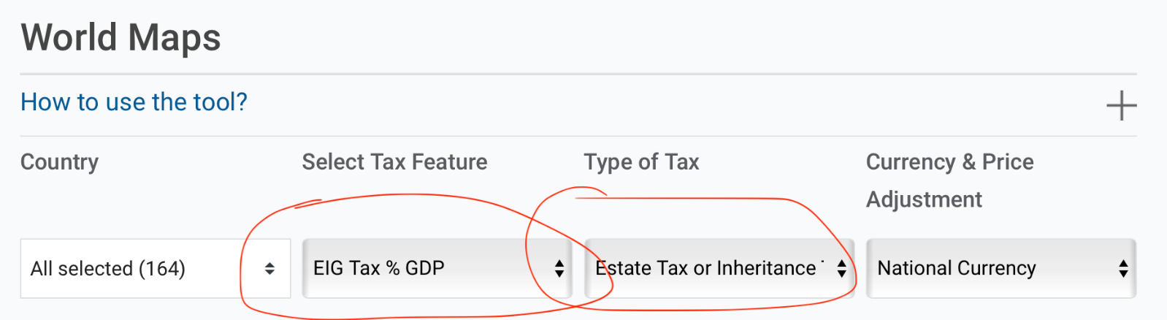

In the old setting - from eigt_wide_viz - this corresponds to:

Value of x_hs_rto_trvgdp IF x_hs_cat_eigsta=="Y"

In the new setting with eigt_wide_viz_v:

Value of revgdp_ei IF status=="Yes" & (tax=="inheritance" | tax=="estate")

Note: Here the underlying assumption is to use the general government level in “applies_to”. Or better, we keep the general level revenues when this is not available, we scale down but only when the local/federal is not 0.

10. EIG Tax in % GDP + Estate Tax (Inheritance)

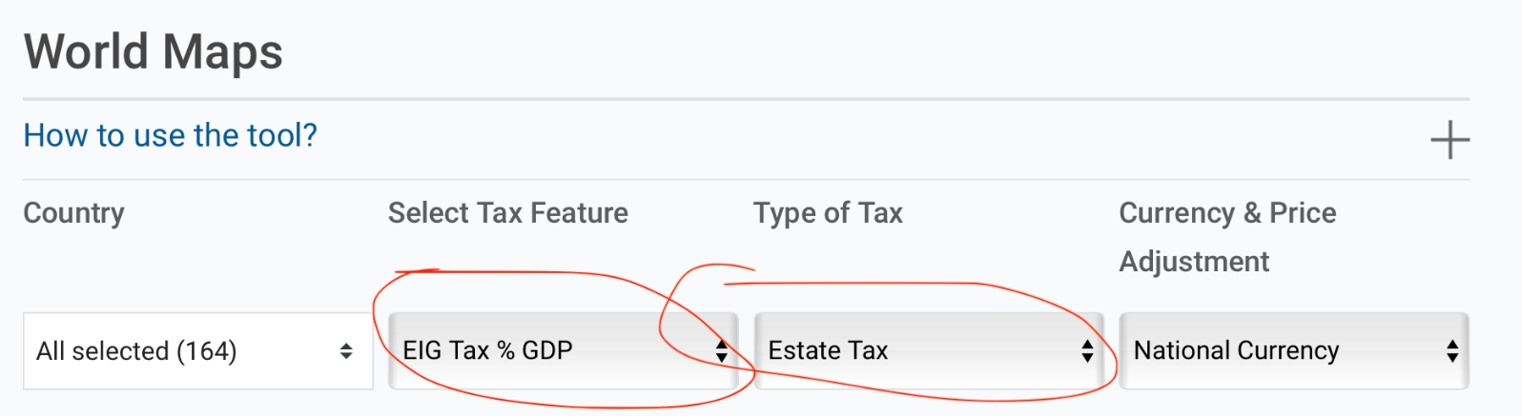

In the old setting - from eigt_wide_viz - this corresponds to:

Value of x_hs_rto_trvgdp IF x_hs_cat_esttax== “Y”
(In the case of Type of Tax = Inheritance, then the above condition is: x_hs_rto_trvgdp IF x_hs_cat_inhtax == “Y“)

In the new setting we may have 2 different scenarios, depending on which filtering condition we want to introduce. Indeed, as the OECD collects revenue for EIG or for EI, or for gift separately, in the new version we may want to show the Tax in % of total tax revenue as for EIG, EI or gift separately.

In this 1st scenario, with eigt_wide_viz_v1 we have:

Value of revgdp_eig IF n_tax==3 - for EIG
Value of revgdp_ei IF (tax==”inheritance” & status==”Yes”) | (tax==”estate” & status==”Yes”) - for EI
Value of revgdp_g IF (tax==”gift” & status==”Yes” ) - for Gift

In a 2nd scenario we can replicate estate and inheritance separately (but each including gift as well, as we do not have information separately):

Value of revgdp_eig IF (tax=="estate" & status=="Yes") & (n_tax>=1 & gift_yes==1) – Filter on estate
Value of revgdp_eig IF (tax=="inheritance" & status=="Yes") & (n_tax>=1 & gift_yes==1) – Filter on inheritance

